Chicken Stir Fry
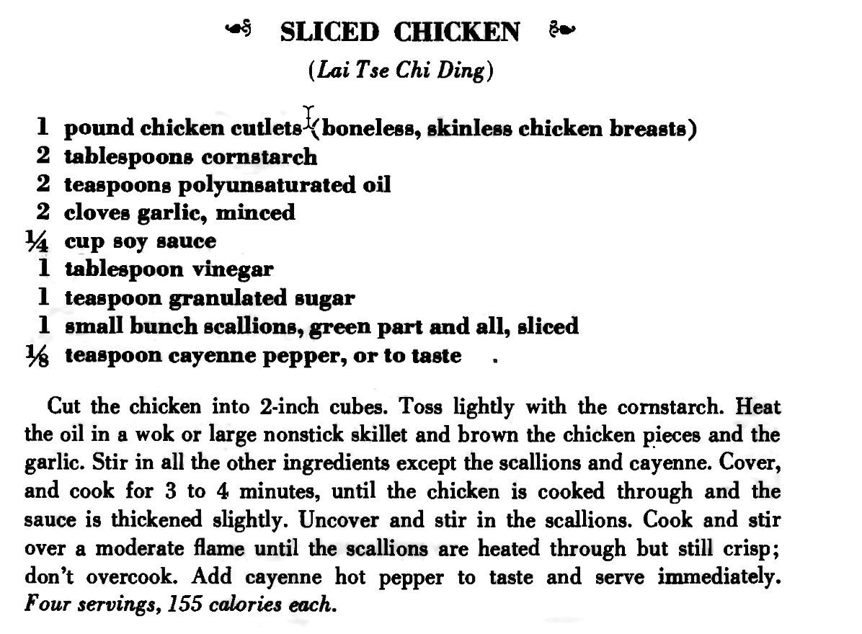

Ingredients & Cost
Ingredient | Cost
1 cup Basmati rice | Costco, $20/20lb bag. | $.50
Broccoli, 1 bag | Trader Joes, 2lb bag, $.xx | 3.69
1 ½ lb. Chicken Breast | Whole Foods, $5.49/lb | 9.04
Cornstarch (3T) | Target, $2.39/16oz | .16
Olive Oil (2 T) | Costco, $22/2L, Kirkland | .33
Garlic (4-8 cloves) | Trader Joes, $.49/head | .49
Soy sauce | United Noodle, $4/bottle, | .95
White Vinegar | Target, $3.89/gal. | .02
Sugar | Costco, $18.50/25 lb | .02
Cayenne pepper | Amazon-Spice way, $7/8oz, | .06
Green onions (scallions), 2 bunches | Whole Foods, $.99/ea | .99
Butter or Sesame oil (for rice)
Total |  | ~$16.25

Wines
Medium red: Rioja, Tempranillo, Grenache, Mencia, Gamay, Carignan, Portuguese, Rose (Provence)
Whites: Sauvignon Blanc, Verdejo, Albariños, Riesling, Vouvray (middle), (Chardonnay – non oak)
Price range: $10-$15. Today, Spanish Monastrell, $10, Costco. A little heavy, but fun!
Cocktail: Martini (vodka/gin)

Rick (text): 563.579.4194

Cooking Supplies
Wok | Amazon, Craft Wok, $60
Wok spoon | Amazon, $12
Wok base | Amazon, M.V. Trading, $14
Scouring pad | Target
Rag | Anywhere
Pot | Anywhere
Pot holder | Anywhere
Plastic bag
Small dish
Mini Chopper | eBay
Measuring cup
Measuring spoon, 1T, 1t
Cutting board | $200 at Boardsmith, Maple
Knife

