[Click here and type Title]

Submitted to: [Click here and type professor's name]

May 10, 1999

By

[Click here and type your name]

Abstract

Table of Contents
Introduction 2
Section 2 2
Using this template 2
Section 4 2
Conclusion 2
References 2

Table of Figures
Figure 1. Word’s Options Setting for Templates 2

Introduction
This is the beginning of the report.

Section 2

Using this template
Make sure that the Workgroup Template setting is pointed to the location of this template document. Do a file|new, and you should see this template’s name. Replace the headings and other information with yours. Note: Use title case in headings so that the headings come into the Table of Contents properly. Use the F9 key to update fields and tables. A sample figure and table are provided, with captions. Remember to use styles wherever possible!
This is a sample Figure, properly formatted. You can substitute your picture. The figure number is a special field that automatically keeps count for all figures (important for automatically updating the Table of Figures).
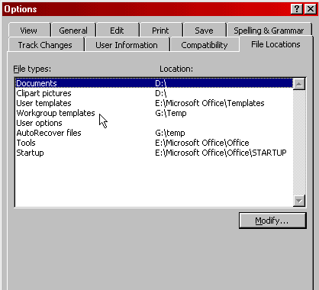
Figure 1. Word’s Options Setting for Templates
Text continues here.

Section 4 (if needed)
This is a sample table, properly formatted with borders. You can substitute your data into it, add or remove columns. The table number is a special field that automatically keeps count for all tables.
Table 1. My first table
Amino Acids | Vernonia Meal | Soybean Meal | Linseed Meal
Arginine | 8.6 | 7.6 | 3.2
Isoleucine | 2.3 | 2.2 | 0.7
 | 4.1 | 4.4 | 1.8
 | 4.1 | 4.4 | 1.8

Conclusion

References
Footnotes will be brought into this References section. However, the format will likely be incorrect and require manual editing. I like to highlight the references, cut them, then paste them back as unformatted text. Using this procedure, you must also go back through the text and eliminate the end note numbers and insert a properly formatted reference form. I agree, I wish Word could do this automatically but I have found no method yet.

Wang, H.P. and Li, J.K., Computer-Aided Process Planning, Elsevier, New York, 1991.

